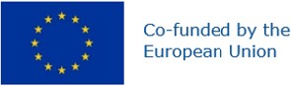
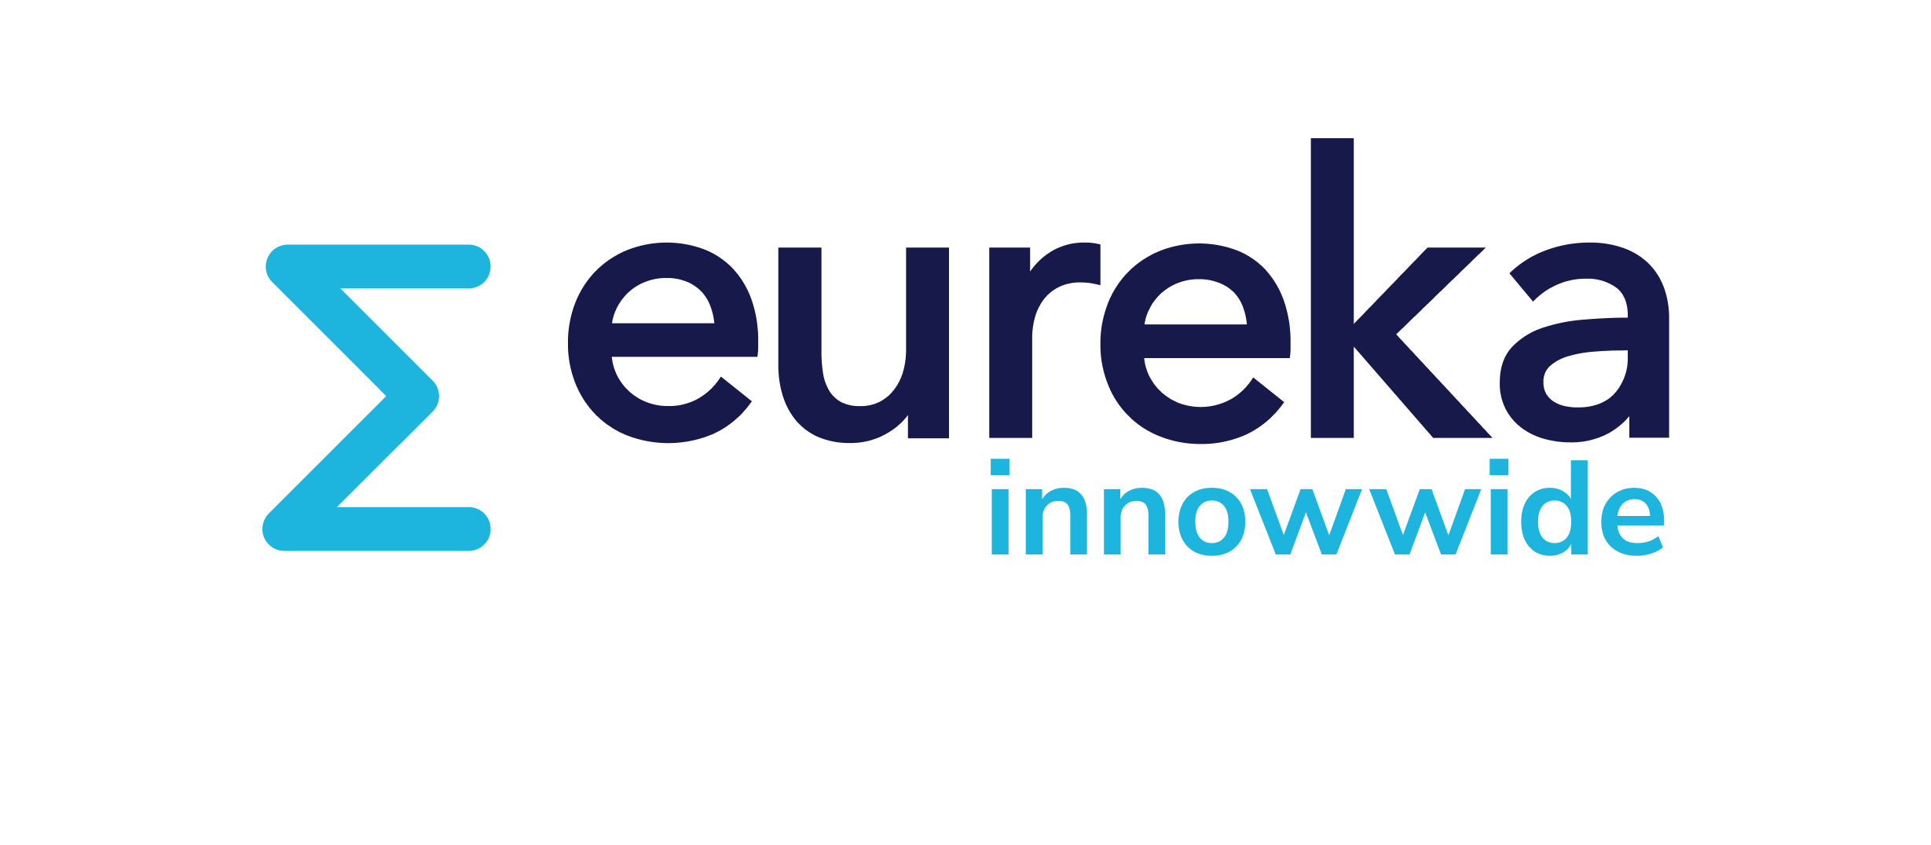
EUROPEAN PARTNERSHIP

European Partnership on Innovative SMEs Innowwide

Application form template

Important notes for applicants

This document is a Word version of the application form for our second Eureka Innowwide call for market feasibility projects. You can use it to work offline on your application.

Please note, however, that this is not the official application form. Innowwide applicants must apply by completing and submitting an online application form via the Eureka SmartSimple portal. Application forms received in any other ways will not be considered.

Key of the type of questions in the application form:
[Text box] = type one of more lines of text, including characters and/or numerical figures.
[Word limit: n] = type one of more lines of text, with a word limit.
[Tick-boxes] = select multiple answers from a list of choices.
[Drop-down] = select one answer from a list of choices.
[Built-in table] = fill in an online table.
[Upload] = upload a pdf file, e.g., workplan.
Instructions = guidance and details on how to reply a question

Version 1.0 (25 July 2023)

Project Description
Project Acronym [Word limit: 4]
Project Title [Word limit: 10]
Project short summary [Word limit: 350]
Note: This short summary will be used in the evaluation process and will be made publicly available in case the project is approved for funding.
This short summary will be sent to your counterpart when you will send them the invitation to approve the commitment form in the platform.
Confirm that your application has an exclusive focus on civil applications
Remember that Innowwide only funds projects with an exclusively civilian purpose. This does not rule out the development of project results that may meet the needs of both civil and military end users (known as 'dual-use' goods or technologies), provided that the project itself has a clear focus on civil applications. Please note: the fulfilment of eligibility criterion 4 (The project has an exclusive focus on civil applications) is verified automatically based on your answer to this question. A further check on the civilian purpose is performed by the ethics panel.
Technical Area [Drop-down]
Specify Technical Area [Drop-down]
Specify Technical Area Further (if applicable)
Market Area [Drop-down]
Specify Market Area [Drop-down]
Specify Market Area Further (if applicable)
Keyword 1 [Text box]
Keyword 2 [Text box]
Keyword 3 [Text box]
Target country [Drop-down]

Local counterpart (main subcontractor)

Full legal organisation name (main subcontractor) [text box]

Country (main subcontractor) [Drop-down]
Your main subcontractor must be based in your target country.
Type of Organisation (main subcontractor) [Drop-down]
SME; large industry; Non-profit private organisation; Public body; University; Research centre; Self-employed professional
Activity Field (main subcontractor) [tick box]
Research / Technological Collaboration; Consultancy; Legal Advice; Brokerage; Branding & Communication; Other
Description of main subcontractor’s company [Word limit: 150]
Briefly describe the main subcontractor, i.e. type of organization, track record, size and its role in the target market.

NOTE: After you fill in the project description section, you will be able to invite your counterpart to sign a commitment in the platform (invitations feature will become visible on the left menu).

SME Status/Commitment

SME Assessment tool [built-in table]
Small and medium-sized enterprises (SMEs) are defined in the EU recommendation 2003/361 (https://eur-lex.europa.eu/legal-content/EN/TXT/?uri=CELEX:32003H0361).
Use this SME self-assessment tool to determine whether your organisation qualifies as a small and medium-sized enterprise. Click on "open" to complete your SME self-assessment.
Remember that branches; departments/centres/offices set up within or under a parent organization and not provided with their own legal personality; and natural persons, will not be considered as eligible within Innowwide calls for proposals.

Staff Headcount [text box]
Criterion for determining whether an enterprise can be considered an SME and, if so, in which category the SME falls.
The headcount corresponds to the number of annual work units (AWU), i.e. the number of persons who worked fulltime within the enterprise in question or on its behalf during the entire year under consideration. The work of persons who have not worked the full year, the work of those who have worked part-time, regardless of duration, and the work of seasonal workers are counted as fractions of AWU.
The staff consists of:
(a) employees;
(b) persons working for the enterprise being subordinated to it and deemed to be employees under national law;
(c) owner-managers;
(d) partners engaging in a regular activity in the enterprise and benefiting from financial advantages from the enterprise.
Annual turnover or balance sheet [drop down]

Annual turnover / Balance Sheet Total (In Euro) [text box]
ANNUAL TURNOVER: Annual turnover is determined by calculating the income that an enterprise received during the year in question (last approved annual accounts) from the sale of products and provision of services falling within the company’s ordinary activities, after deducting any rebates. Turnover should not include value added tax (VAT) or other indirect taxes.
ANNUAL BALANCE SHEET TOTAL: The annual balance sheet total refers to the value of a company’s main assets

Proposal - The Pitch

What do you want to do? [Word limit: 150]
Here you should summarise the Excellence section of your proposal.

Why do you want to do it? [Word limit: 150]
Here you should summarise the Impact section of your proposal.

How will you do it? [Word limit: 150]
Here you should summarise the Implementation section of your proposal.

Proposal - Excellence

Objectives
Objectives of your project [Word limit: 300]
Describe your innovative solution and the objectives of your project. Describe how ambitious is your project and what the main result will be. Highlight why your project should be funded.
Competitive advantage of your proposed solution [Word limit: 250]
Describe the state-of-the-art in your project’s field. Describe how your project goes beyond what currently exists in the target market. Identify the main competitors and describe in which aspects (cost, quality, efficiency, benefits for the end users...) your proposal has an advantage over the competitors.
Stage of innovation in the home market, the target market and globally [Word limit: 150]
Describe where the proposed innovative solution is positioned in terms of R&I maturity. Where applicable, provide an indication of the Technology Readiness Level (TRL), if possible in the beginning and by the end of the project.
The home market [Drop-down]
The target market [Drop-down]
Globally [Drop-down]

Alignment with the business strategy of your company [Word limit: 150]
Describe how the project objectives align with the business strategy of your company and how your expected expansion supports the long-term goals of your SME.

Type of feasibility assessment proposed
The list presented below constitutes the fixed and exhaustive list of activities eligible for funding in the frame of the “Eureka Innowwide Call for proposals”. To be eligible, your application must include elements from sections 1, 2 and 3 (market and technical activities) and can include (but not exclusively) elements from sections 4 and 5 (business development and promotion).
NOTE: The activities that you select in this section will be need to be budgeted for.

- Cocreation or technology uptake facilitation (innovation and tech transfer services) [Tick-boxes]
  - Definition of a complementary joint RTDI Project for cocreation or technology adaptation (including where appropriate, frugal innovation) with the local strategic subcontractor
  - Analysis of the IP environment
  - Technology scouting and novelty verification
  - Technology valuation (economic)
  - Technology legal situation analysis
  - Technology protection & valorisation strategy design
  - Certification and homologation compliance verification
  - Technology partnership matchmaking
  - Small scale proof of concept (trial and assimilation, further RTDI preparatory work)
- Market prospection - (desk & field studies) [Tick-boxes]
  - Business opportunities early survey detection (pre-conceptualisation)
  - Qualitative analysis (consumer analysis: segments, preferences, patterns, motivations, opinions, attitudes, values, culture, …)
  - Product commercial research (local customer experience oriented: concept, design, supply, use…)
  - Market quantitative analysis (real, potential, tendencies)
  - Competition analysis (market share, positioning, value propositions, value chains…)
  - Analysis of potential partners for distribution and marketing
  - Analysis of potential suppliers
  - PESTLE Analysis (political, economic, sociological, technological, legal and environmental issues) and market barriers analysis
- Compliance verification [Tick-boxes]
  - Administrative & legal FTO / due diligence verification
  - Social and cultural best practices identification and implementation planning
- Business prospection trips (duly justified) [Tick-boxes]
  - Trade fairs/ conferences/ info days/ networking and matchmaking events
  - Joint workshops/ meetings with potential partners
  - Workshops with partners to prepare joint R&D proposals/ projects
- Specific promotional technical material preparation (technology valorisation oriented) [Drop-down]

Please present justification for specific technical promotional material preparation [Word limit: 100]

Foreseen technological adaptation to the target market [Word limit: 200]
Describe if and how the proposed innovative solution will need to be adapted for the target market. Describe if your market feasibility project is going to facilitate significant and relevant further co-creation. Consider, if appropriate, frugal innovation.

Foreseen R&D project (post-market feasibility project) [Word limit: 250]
Describe if you intend to develop a future RTDI project with the local counterpart (post-market feasibility project) in the target country. If a future R&D project is not envisaged, please add N/A.

Proposal - Impact

Target market and potential end users

Project Expectations

Prior experience in the target market [Drop-down]

Estimation of Market [Built-in table]

End users and user needs [Word limit: 200]
Indicate who are the envisaged end users. Describe the most relevant market segments and how the targeted users will be reached. Describe the identified user needs and the added value/main benefits (social/economic/environmental) of your product, process or service for potential end users in the target market.
Relevance for the target market [Word limit: 150]
Describe how the innovative solution is relevant for the target market.
Impact on the main subcontractor [Word limit: 150]
Describe the expected impact on the main subcontractor, including potential scale-up and job creation.

Market Potential [built-in table]

Indicators:
Revenue Expectations
Employment / Intellectual Property expectations
Market Share / Profit Margin Expectations

Commercialisation plan

Commercialisation plan and market expansion [Word limit: 350]
Describe what would be needed for you to better fit towards existing competition in the target market. Describe how you plan to commercialise your proposed product/process/service.
If you intend to continue exporting your innovation beyond the initial target market, describe how, and indicate the timeframe.

Pathways from idea to market [Word limit: 150]
Describe the project actions and positioning pathways from idea to market.
Market barriers [Tick-boxes]

Description of market barriers and mitigation plans [Word limit: 350]
Provide an explanation of choices above (potential barriers to market entry), and any mitigation actions you would take, in particular ways of reducing time and cost to market.
Intellectual Property [Word limit: 150]
Indicate the key items of intellectual property that you will use and who owns them.

Social and environmental impact

Sustainable Development Goals [Tick-boxes]
Select the UN Sustainable Development Goals your project will contribute to.
Note: This information may be made publicly available in case the project is approved for funding.
Description of the project's contribution to the UN SDGs [Word limit: 150]
Describe how your project will contribute to the selected UN Sustainable Development Goal(s).
Social and environmental risks [Word limit: 150]
Describe any potential negative social and/or environmental effects that your project or project results may have and any envisaged mitigation measure.

Proposal - Implementation

Team and Resources

Applicant’s team [Word limit: 250]
Briefly describe the applicant’s team and how their profiles match the projects’ objectives.
Subcontractor’s team [Word limit: 250]
Briefly describe the subcontractor's team and how their profiles match the projects’ objectives.
Complementarity of the main subcontractor and benefits of collaboration [Word limit: 250]
Describe how the main subcontractor complements your company, what is the added value, and what mutual benefits can be expected from the collaboration in this project. Describe how cooperation could extend beyond the lifetime of the project.
Are any other subcontractors envisaged in addition to the main subcontractor? [Drop-down]
No; Yes;
If yes, provide a short overview of the expected services and profiles of minor subcontractors.
Availability of resources required (personnel, facilities, networks, etc.) [Word limit: 150]
Describe which resources would be required to carry out the market feasibility project, indicating if they are already available or if, and how, they would be acquired.
Does the team have previous experience with internationally funded cooperation projects? [Tick-boxes]
Gender dimension [Word limit: 150]
Describe how the gender dimension is taken into account in the project.
Gender CEO [Drop-down]
We collect this information for data purposes only. We do not consider it when evaluating your proposal.
Number of male staff working on the project in the applicant's team [Text box]
Number of female staff working on the project in the applicant's team [Text box]
Number of male staff working on the project in the subcontractor's team [Text box]
Number of female staff working on the project in the subcontractor's team [Text box]

Work Plan

Summary work plan [Word limit: 250]
Brief presentation of the overall structure of the work plan
Please upload a detailed workplan description [upload a PDF workplan (template provided)]
1. Download the editable template (available to download in the platform)
2. Fill it in, remove the example page
3. Convert into pdf
4. Rename the file as 'Project ID_Acronym_workplan' (e.g., 2023-12345_LOREM_workplan)
5. Upload
Gantt chart [Built-in table]

Budget
Add budget details [Built-in table]
Eligible costs: personnel, subcontracting, purchasing costs (travel and subsistence, equipment depreciation, other goods, works and services) and indirect costs (automatically calculated on the basis of a 25% flat-rate of the total direct eligible costs, excluding subcontracting).
The budget for your proposal must be established in accordance with your usual cost accounting practices. Purchases and subcontracting costs must be done taking into account best value for money and must be free of conflict of interest.
Below you will find a list of previously selected activities from the excellence section that are eligible for funding under the Innowwide programme. Input those activities in the table using the activity dropdown menu and provide budget information for each.
Use the designated subcontracting column for all costs (including personnel) related to activities carried out by your subcontractor(s). If selected for funding, you must provide a signed contract with your main subcontractor for a value reflecting the one indicated in the subcontracting column.

Ethics Self Assessment
All applicants are required to complete the ethics self-assessment for their proposal, regardless of whether they consider that their proposed work raises ethics considerations or not.

Declaration of Honour

